NAME:MUHAYIMANA21@GMAIL.COM

REG:221003300

DATE:02/08/2022

**INTRODUCTION**

Online hotel reservations website are **a popular method for booking hotel rooms**. Travellers can book rooms on a computer by using online security to protect their privacy and financial information and by using several online travel agents to compare prices and facilities at different hotels.he data is then passed onto a backend system which can be accessed by hotels to manage bookings. Other features may come with it – for example, the automation of reservation confirmation emails. A hotel reservation website enables guests to schedule dates and length of stay, room selection, extras, and payment all in one place. Most of the tourist they can book the hotel from the airport via online.

The online booking system works all the time. It also increases your sales because you are not limited to your working hours. This gives freedom to potential visitors to book a room anytime and anywhere they want. Show that 24*7 online reservation system considerably increases the number of hotel bookings.

**PROBLEM STATEMENT OF ONLINE HOTEL RESERVATION**

Hotel reservation website will make your work more effective. They all are want to be tied to a waiting a mail or phone call of a guest. They will be able to take bookings around the 7 days a week.

Work smart insights into your business

They can keep track of each reservation and all the related details. Such systems come with various analytic tools. You will have to all the information to better understand the guest, what they favored and what updation you have to need in your business. You need to focus on the week part of your business. To grow up your business.

Increase revenues thanks to upselling

A second major benefit of online hotel reservation system, you can easily promote your business through the social media online to create a page or start a campaign and sell packages, add-ons online. Let customers choose the package they want. You can generate a business from here or increase the income.

Payments are easier and faster

Payments mode are also easy with the online booking platform. If some of your guests have come, so you can book a room without telling him for surprised. You can pay the charges of room and food as a form of a gift. A major benefit of an online hotel reservation system.

Cut your workload

hotel booking app reduces workload for your staff and optimizes consumer service, make sure that booking are synced and the possibility of availability is updated with the each of booking process. The symbol of a good home reservation system makes the work process carefully.

New booking trend

The preponderance of the customers use the internet in this digital world, they discover on the internet everything they need to know. If your business is not showing online you can miss a great opportunity. If you want to take advantage of this modern booking approach, you must integrate your business online reservation platform with your product, service pages. You can take a great business through the internet online services.

**OBJECTIVE STATEMENT OF ONLINE HOTEL RESERVATION**

The purpose of an online hotel website is to allow potential customers to self-book and pay through your website, securely store customer's data, manage your staff and keep your business running long after you've gone home for the day. And that just scratches the surface also hotel reservation system enables guests to schedule dates and length of stay, room selection, extras, and payment all in one place.

**PROJECT RATONALE OF ONLINE HOTEL RESERVATION WEBSITE**

There’s a range of benefits to having this technology in place at your hotel, mostly based around simplifying your life as a manager or staff member and speeding up a number of processes. They include:

No need for the front desk staff to process reservations – when guests can input their own reservation details through the systems everything happens automatically and your staff don’t need to worry.

With guests inputting their own details there’s less chance of the wrong data being entered. If something does go wrong you’ll have a record to prove it wasn’t your fault.

A large amount of guest data can be captured by these systems, allowing you to improve both marketing and guest service

Better management and tracking of rewarding guests for their loyalty

There’s a range of benefits to having this technology in place at your hotel, mostly based around simplifying your life as a manager.

An online hotel reservation website feeds a huge amount of guest data right into your system: how many guests are travelling, when they come, what amenities they prefer, where they live, and so forth. That's very useful for you to know, and will help you improve both customer service and marketing

An online hotel reservation website works all the time. This gives freedom to potential visitors to book a room anytime they want. It also maximises your sales because you are not limited to your working hours. In fact, studies show that a 24/7 online reservation system greatly increases the number of hotel bookings

**METHODS AND METHODOLOGY USED ON ONLINE HOTEL RESERVATION**

For example, a reservation request may reach the hotel through traditional methods like a written mode such as letter, fax, telex or e-mail or through a verbal mode like telephone or in-person etc. In this modern era, the majority of the reservation is via online modes like website, mobile apps, social media etc.

**TOOLS USED ON ONLINE HOTEL RESERVATION**

HARDWARE TOOLS

Processor 2.8ghtz

RAM 4 MB

Hard disk 500 GB

Monitor 15” color monitor

Key

1.computer

2.desk

3.table

4.telephone

5.etc

**SOFTWARE TOOLS OF ONLINE HOTEL RESERVATION**

Operating System Windows 10

xammp

Language PHP Runtime Environment

Database MySQL Server

Browser Any of Mozilla, Opera, Chrome etc

Web Server Apache

Scripting Language Enable Javascript

**REQUIREMENT SPECIFICATION OF ONLINE HOTEL RESERVATION**

There is a number of basic requirements every good reservations system should have, both functional and non-functional. They include:

**FUNCTION REQUIREMENTS OF ONLINE HOTEL RESERVATION**

Associate every online booking with an account

Limit every account to a single user

Enable users to search and find the most relevant booking options

Accept date and time to check available rooms for that particular time

Booking confirmation should be sent to the specified contact details

Calculate and display accommodation charges and other utilities

Cancel bookings

Display and change records of guests

Change rooms

**DATA REQUIREMENTS OF ONLINE HOTEL RESERVATION**

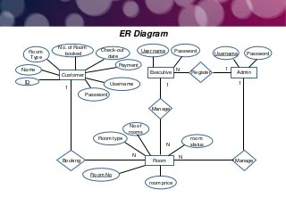

**USER REQUIREMENTS OF ONLINE HOTEL RESERVATION**

1.User

2.Admin

2.Recepoinist

**SECURITY REQUIREMENTS OF ONLINE HOTEL RESERVATION WEBSITE**

Protect sensitive cardholder information by encrypting it. Have up-to-date antivirus software on all your systems. Have administrative accounts for the management people in your business to your booking solution. Make credit card information accessible only on a need-to-know basis.

Security keys: A secure booking system protects your data against eavesdropping, corruption, masquerading, and denial of service attacks by using a combination of Public Key Cryptography, Private Key Cryptography, and Hash Function.

Hacker safe: Daily scans to clean malware using AntiVirus software makes sure your systems are secure and you are protected against potentially dangerous attacks. No system or software is perfect but having AntiVirus software adds a strong layer of security to your system.

**NON_FUNCTION REQUIREMENTS OF ONLINE HOTEL RESERVATION**

Use encryption to avoid bots from booking

Search results should populate within acceptable time limits

Users should be helped appropriately to fill in the mandatory fields, in case of invalid input

System should accept payments via various payment methods

Easy to use, efficient, and accessible

Keep track of documentation, activities, and responses

The main point to remember is that this technology enables guests to choose and book their own rooms online via secure portal. It must be straightforward and safe, but it must also offer you the same convenience and range of use it does your guests. This way, it won’t only make life easier but you can use the data it provides to source more revenue and profit for your hotel.

**SYSTEM DESIG**

CONTACT US

VIEW

REGISTER

ABOUT

HOME

admin

user

Register now

**SYSTEM IMPLEMENTION OF ONLINE HOTEL RESERVATION WEBSITE**

DISCOVER LUXURY PAGE OF ONLINE HOTEL RESERVATION WEBSITE

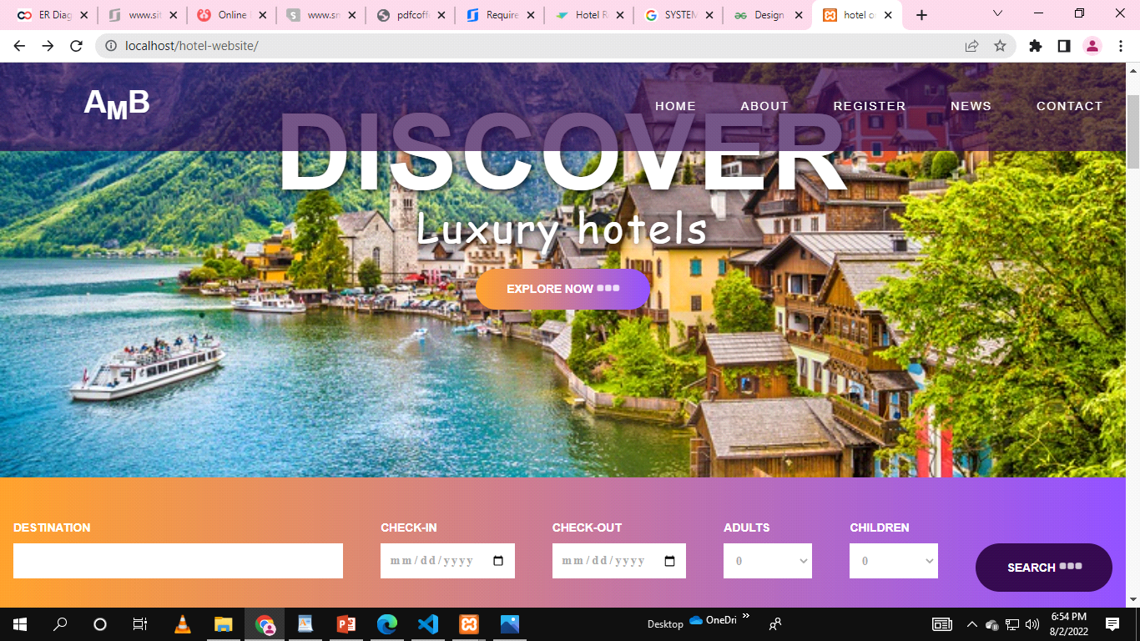

REGISTER PAGE OF ONLINE HOTEL RESERVATION WEBSITE

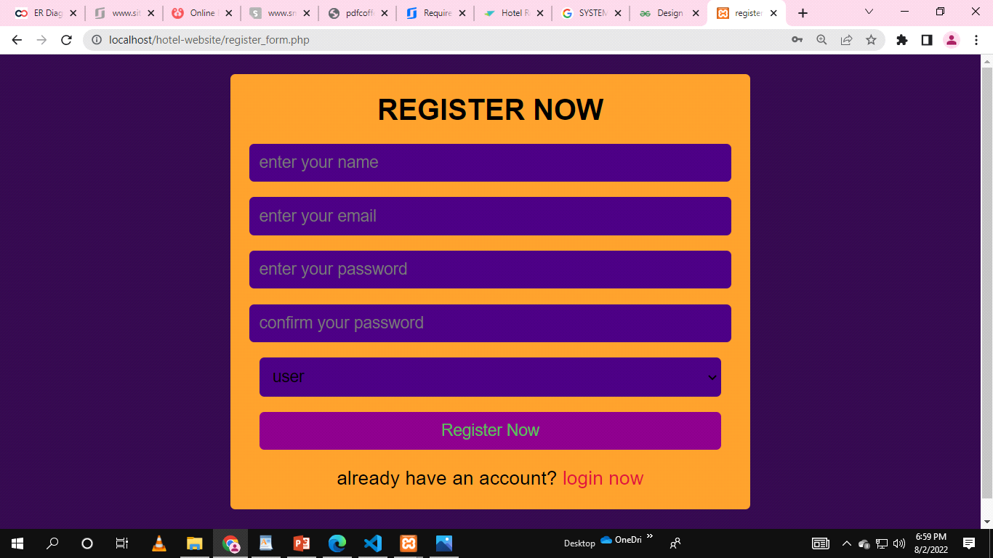

LOGIN PAGE OF ONLINE HOTEL RESERVATION WEBSITE

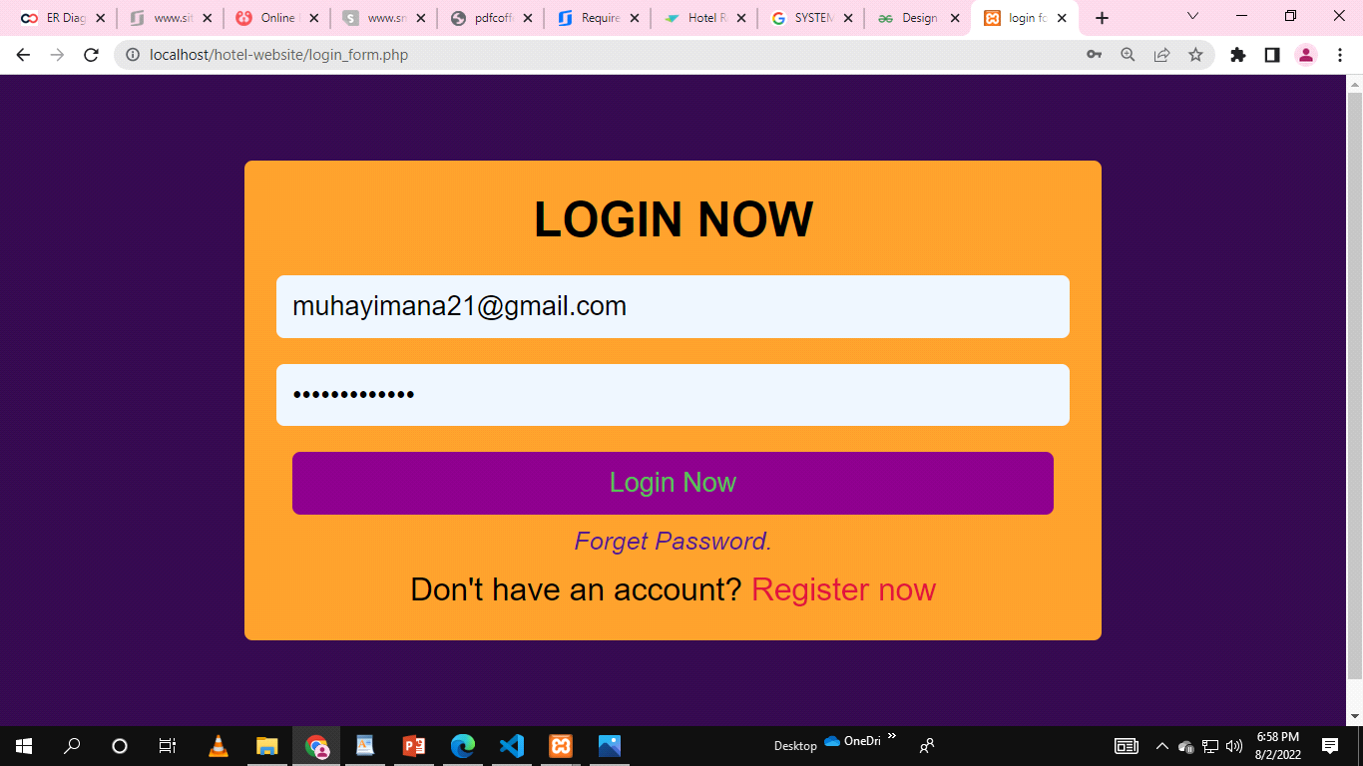

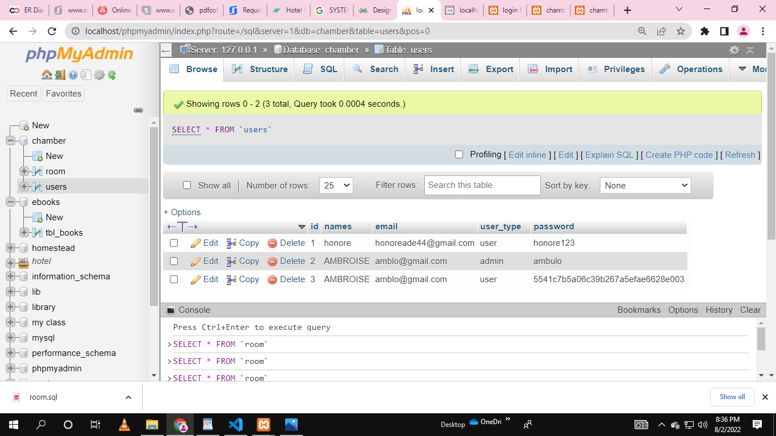

**AFTER USER LOGIN AND LOGIN AGAIN**

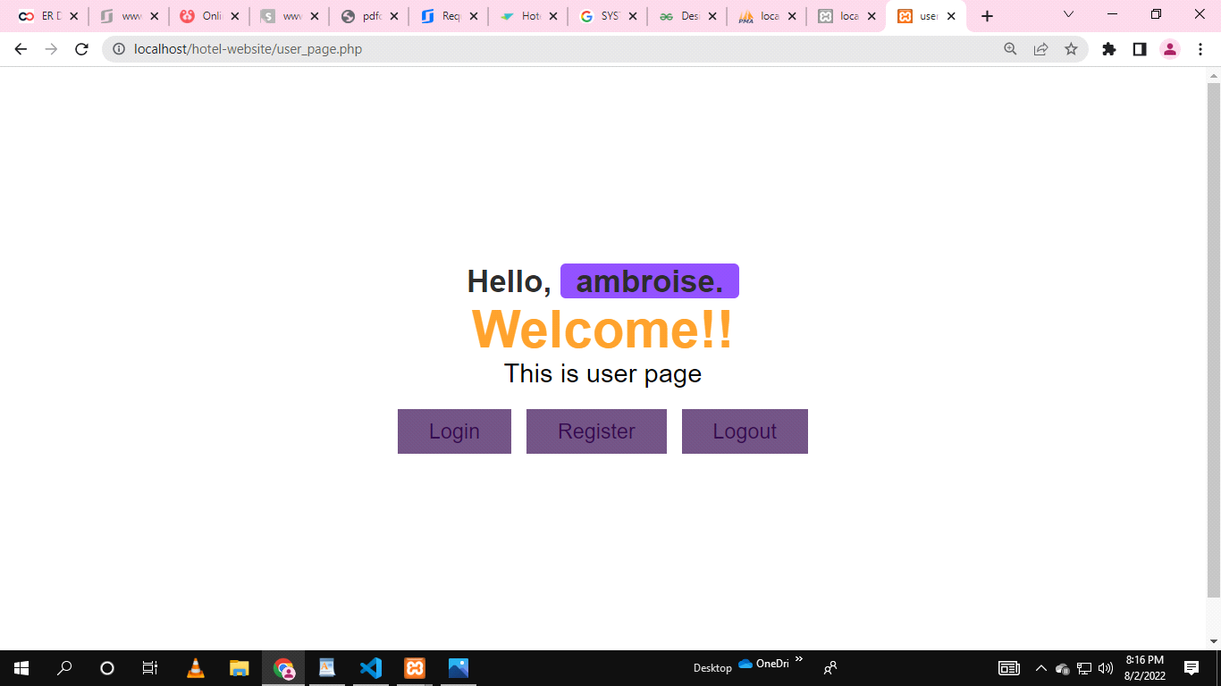

CHAMBER PAGE OF ONLINE HOTEL RESERVATION WEBSITE

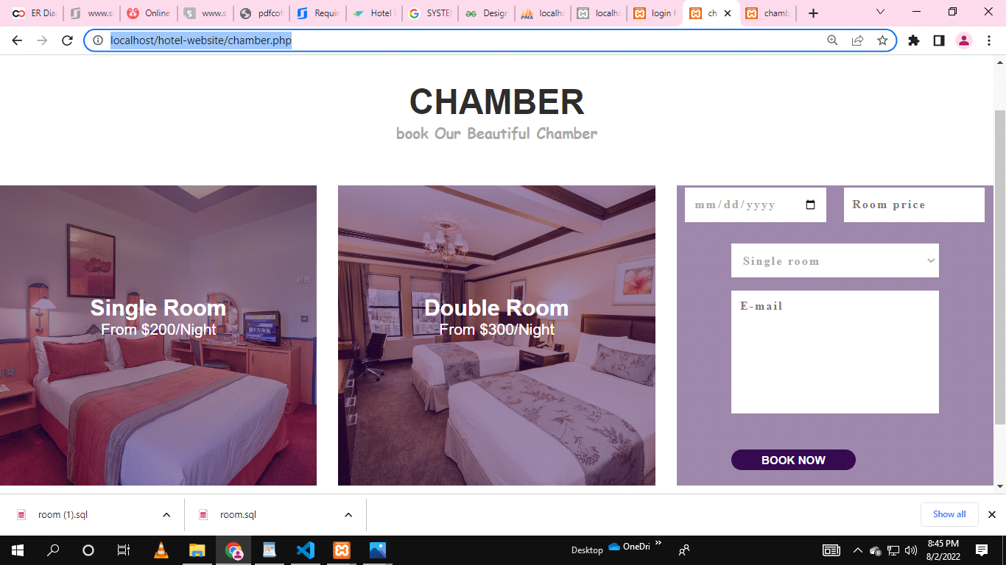

AFTER BOOKING CHAMBER DATA IN DATABASE

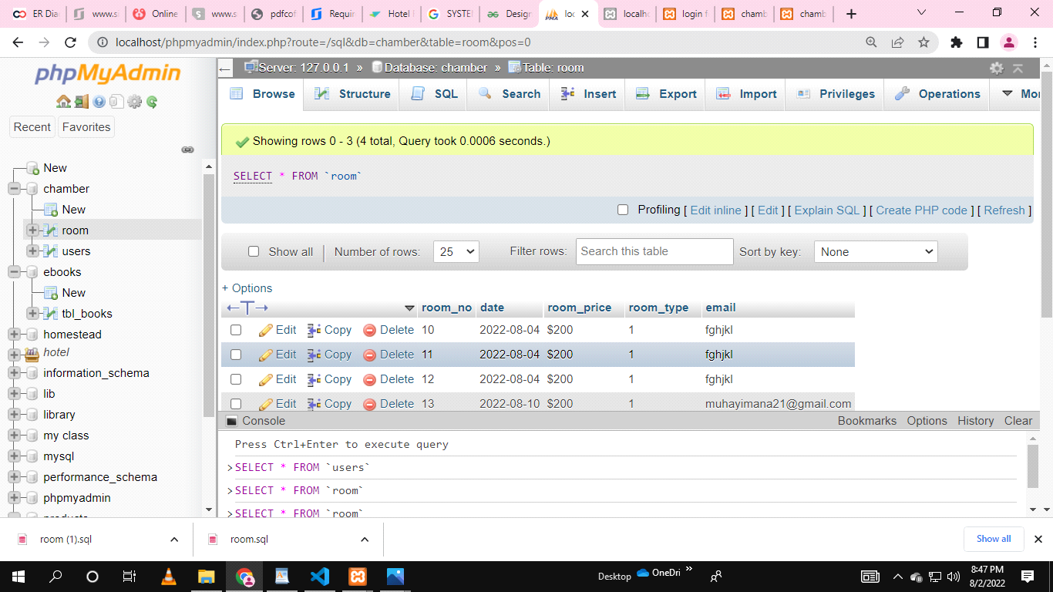

**Conclusion of the Project HoteL online hotel reservation:**

My project is only a humble venture to satisfy the needs to manage their project

work. Several user friendly coding have also adopted. This package shall prove to be a

powerful package in satisfying all the requirements of the school. The objective of

software planning is to provide a frame work that enables the manger to make

reasonable estimates made within a limited time frame at the beginning of the software

project and should be updated regularly as the project progresses.

At the end it is concluded that we have made effort on following points…

• A description of the background and context of the project and its relation to work

already done in the area.

• Made statement of the aims and objectives of the project.

• The description of Purpose, Scope, and applicability.

• We define the problem on which we are working in the project.

• We describe the requirement Specifications of the system and the actions that

can be done on these things.

• We understand the problem domain and produce a model of the system, which

describes operations that can be performed on the system.

• We included features and operations in detail, including screen layouts.

• We designed user interface and security issues related to system.

• Finally the system is implemented and tested according to test cases

So my project is not going at the end now but i am continuing to finish it so, i excepect to finish it at 100% about few days. and because i am not finish totaly my project i except to have 96% marks about it so, thanks for every thing.

**Recommandation of the Project Hotel online hotel reservation**

**lessons learened**

**.html**

**.css**

**.php and**

**.mysql**

Hotel online resevation website recommendation is one of the most used application areas in recommendation systems. So far, many hotel recommendation systems have been proposed. Most of these systems are based collaborative filtering, content-based filtering, and association rule methods and employ the features of hotel, the ratings given by user, online reviews and comments in social network about the related hotel as data. However, due to the difficulty of processing the data used, the performance rates and speeds of these methods are relatively slow. As a solution to these problems in this paper, we propose a novel hotel recommendation system based on link prediction method. For this purpose, a customer-hotel bipartite network was first constructed and the relationship information in this network was used as data. Then, a supervised link prediction method that consider customers’ location was presented. To the best of our knowledge, this is the first study that recommends hotel by using link prediction method. The experimental results conducted on data crawled from TripAdvisor.com demonstrate that the proposed method captures an accuracy of 89.5% and outperforms the other recent related algorithms.

**APPENDEX**

<https://github.com/ambroisegithub>